1. **Plot the two likelihood functions and the posterior distribution in a graph.**

To plot the likelihood functions of the audio and visual signals and the posterior distribution we use the code below:

| % Plotting the likelihood functions for the audio and visual signals in red % and blue and the posterior distribution in green figure(1) clf plot(angles,likelihoodAudio,'r') hold on plot(angles,likelihoodVision,'b') plot(angles,posterior,'g') legend({'Audio likelihood','Visual Liklihood','posterior'}) xlabel('Angles in degrees') ylabel('Probability Density') title('Multisensory Integration') |
| --- |

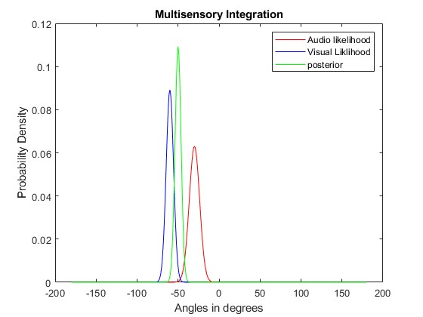

**2. Estimate the parameters of the posterior distribution and determine whether the value of its mean and reliability corresponds to what you can predict analytically from MLE.**

To determine the values of the mean and reliability correspond to what we can predict analytically from MLE we used the code below:

| % Determining the values of the mean and reliability correspond to what we can predict analytically from MLE meanPosteriorPred=(meanLikelihoodAudio+meanLikelihoodVision) / (reliabilityAudio+reliabilityVision) variancePosteriorPred=1/(reliabilityAudio+reliabilityVision) |
| --- |

| meanLikelihoodAudio | -30.0000000000000 |
| --- | --- |
| meanLikelihoodVision | -60 |
| meanPosterior | -50 |
| variancelikelihoodAudio | 40.0000000000000 |
| variancelikelihoodVision | 20 |
| variancePosterior | 13.3333333333333 |

Comparing these equations with the MATLAB code, we can see that the values of the mean and variance of the posterior distribution calculated using the code match the values predicted analytically from MLE.

**3. Plot the likelihoods and the posterior and comment on the values obtained.**

After making the reliability estimates of both audio and visual signals equal to 0.05 and increasing the discrepancy between the two sources (audio -60 and visual 60) we get the plot:

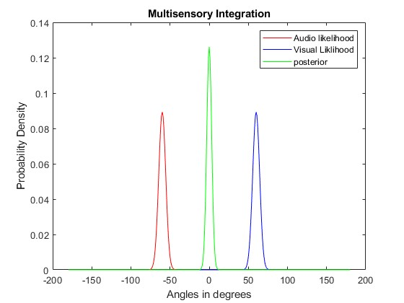

Since the reliability estimates of both signals are set the same, both have the same peaks but with a much larger discrepancy in two different directions. The variance is halved and the posterior distribution peak is higher compared to the previous one but is in the middle as predicted based on the large and equal discrepancy between the two sources.

**4. Generate and display the prior used by Roach et al. (2007)**

We are setting the w to 0.0001 and sigma_p to 1

To generate the prior we use the code below:

| %% % Generating a 2D image of the prior where the x-axis corresponds to visual angles and the y-axis corresponds to auditory angles. The color of each pixel indicates the probability density of the corresponding pair of angles. prior = w+exp( - 1/4 * (angles_a.^2 - 2*angles_a.*angles_v + angles_v.^2) /sigma_p^2) ; prior=prior/sum(sum(prior)); % Display the prior figure(1) clf imagesc(prior) axis equal tight colorbar title('Prior') xlabel('Visual angle (degrees)') ylabel('Auditory angle (degrees)') |
| --- |

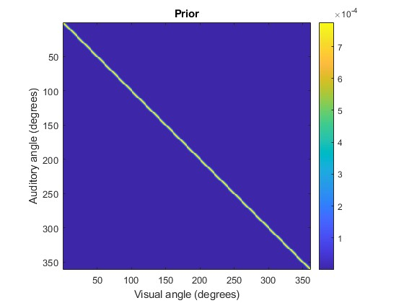

**5. Comment on the report on what happens when you change the values of Sigma_p and w to the shape of the function.**

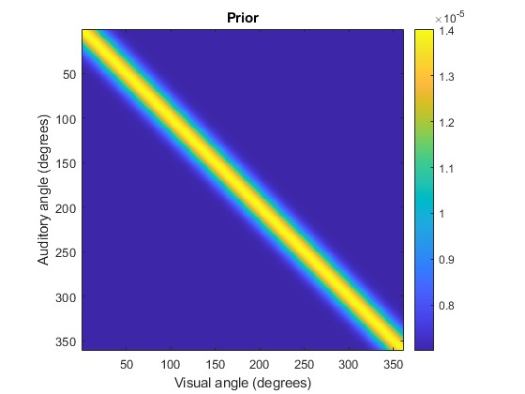

Changing the value of w to 1 and sigmaPrior to 10 will make the prior distribution more sharply peaked around the center (angles_a=angles_v=0) and the constant term w will add a uniform offset to the distribution. This means that the prior will have a higher value near the center and decrease more rapidly as the angles move away from the center in any direction.

**6. Using the values specified in (1) and (2) of the previous sections, display a bivariate likelihood distribution. Calculate the posterior distribution for the two positions of the audio source.**

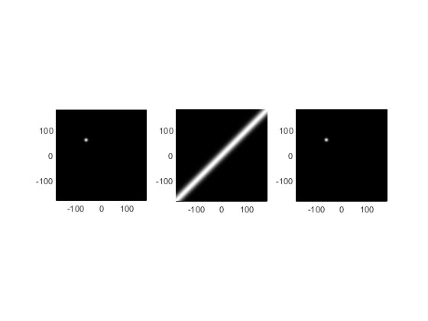

The position of the posterior distribution for the two sources is around -60 and 60 degrees.

**7. Find a good way to display the two posteriors (once for the -60 +60 case, the other for the -30 -60 case). Remember to label the figure.**

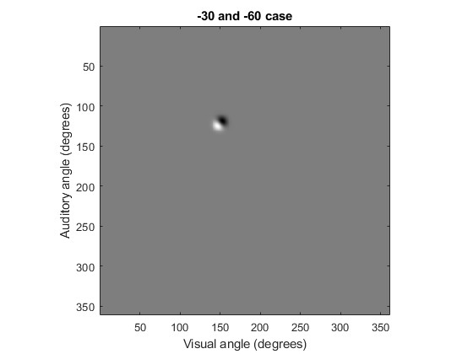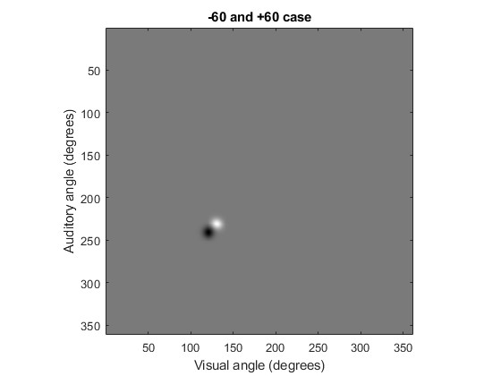

**8. Compare the results with what you obtained in the 1D and the 2D cases and comment. Is the posterior similar to what you would expect? Try to relate the two results to the causal inference model.**

Using the principle of maximum likelihood and sensor data, we can estimate the location or angle of a source with some accuracy. The resulting posterior distribution reflects our updated belief and aligns with the causal inference model. The likelihoods from the sensors update our prior belief and are used to calculate the posterior distribution. The resultant posterior distribution observes a shift between them because of the discrepancies in the position. This principle applies to all cases of estimating a source location or angle. It involves starting with a prior belief and updating it based on the likelihood function and available data to obtain the posterior distribution, which represents our updated belief about the variable of interest.